Data Visualization & EDA: Quiz

1. A white background with black text

   Description automatically generated

Scatterplots are typically used to display two dimensions of data, with one variable on the x-axis and another on the y-axis. However, additional dimensions can be represented using other visual elements such as color, size, or shape of the data points. For example, a third dimension can be shown through the color of the points, and a fourth dimension through the size of the points. Therefore, scatterplots can potentially display more than two dimensions of data simultaneously.

1. 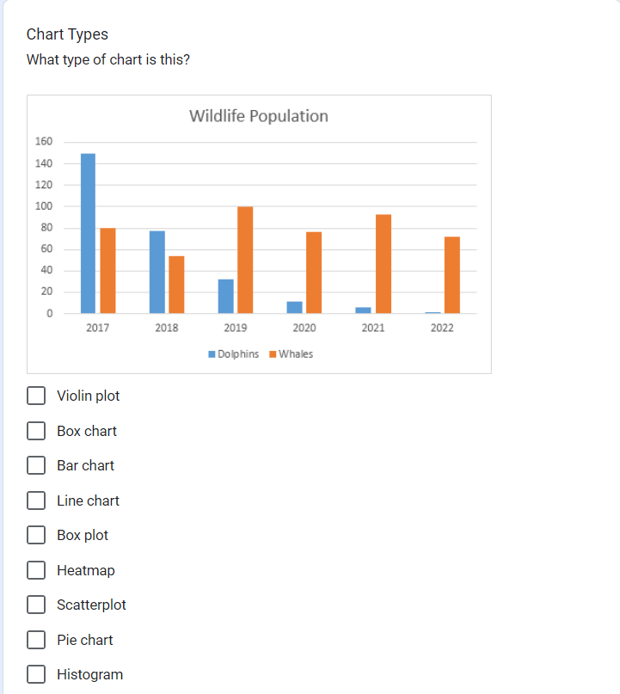

The chart displayed in the image is a **Bar chart**. This type of chart is used to represent data with rectangular bars where the lengths of the bars are proportional to the values they represent. In this case, the chart shows the population of dolphins and whales over different years using bars of different colors.

1. A screenshot of a graph

   Description automatically generated

1. A screenshot of a computer

   Description automatically generated

Link to the dataset: <https://raw.githubusercontent.com/vincentarelbundock/Rdatasets/master/csv/boot/nuclear.csv>

The data description file is at <https://stat.ethz.ch/R-manual/R-devel/library/boot/html/nuclear.html>

1. A close-up of a computer screen

   Description automatically generated

1. A screen shot of a graph

   Description automatically generatedA black and white text

   Description automatically generated with medium confidence

Answer – ‘increase’

1. A screenshot of a computer program

   Description automatically generatedA black and white text

   Description automatically generated